 | NOTICE OF  WITHDRAWAL | .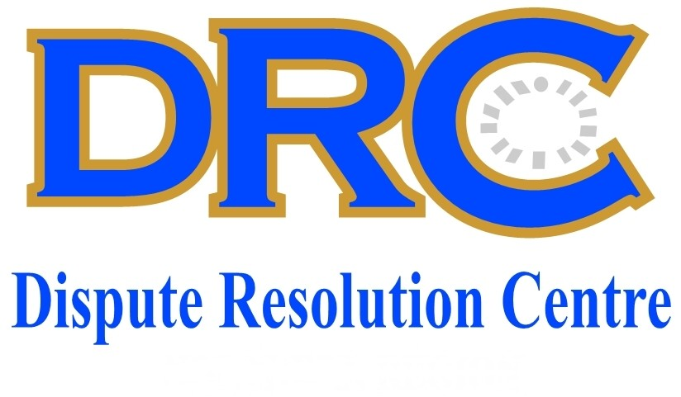
Read This First  WHAT IS THE PURPOSE OF THIS FORM?  This form notifies the DRC that a referring party wishes to withdraw either a referral for conciliation (including con/arb), or a request for arbitration.  WHO FILLS IN THIS FORM?  The applicant party or his / her /their mandated representative  WHERE DOES THIS  FORM GO?  All parties to the dispute, as well as the Provincial Office of the DRC.  OTHER INSTRUCTIONS  A copy of this form must be served on the other party  The parties are advised that the withdrawal of a referral or request for arbitration does not prevent the applicant party from reinstituting proceedings by referring a fresh dispute on the same cause of action, or to file a fresh request for arbitration, except if the withdrawal forms part of a full and final settlement.  Should the applicant reinstitute proceedings by referring a fresh dispute, or filing a fresh request for arbitration, the provisions of the DRC Rules relating to time periods for the filing of documents, as well as applying for condonation for the late filing of documents, will apply. | - APPLICANT PARTY  Name:  Tel: Fax:  Cell: E-Mail:  - RESPONDENT PARTY  Name:  Tel: Fax:  Cell: E-Mail:  Contact Person:  - WITHDRAWAL OF REFERRAL / REQUEST FOR ARBITRATON  I/we  hereby  withdraw the referral for conciliation (including con/arb)  withdraw the request for arbitration  - CONFIRMATION OF ABOVE DETAILS:  Name:  Position:  Signed  Date:  DRC (Dispute Resolution Centre) a Division of MIBCO (Motor Industry Bargaining Council) cares for your privacy. That is why we have taken appropriate measures to ensure that the data you provide to us is always secure. We are fully Compliant with the Protection of Personal Information Act No. 4 of 2013. To learn more about how we comply with Popi Act 4/2013 and, as a result, care for the security and privacy of personal data we collected from you, please visit : www.mibco.org.za.
 | DRC Ref. Number…….……….…..…………..

